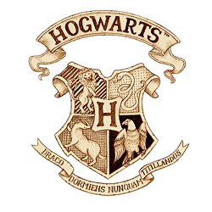

Ricks Family
Lots of 1s and 0s
Middle of Nowhere

Dear Ricks Family,
We are pleased to inform you that one of you has been accepted at the Hogwarts School of Witchcraft and Wizardry.
Please find enclosed a list of all necessary books and equipment, in the form of a muggle QR code. Please scan this code and watch the muggle “video” before continuing.
Term begins December 25th. To decide what member of the house will be awarded the honor of attending our school, you must engage in a friendly duel amongst yourselves.
May the odds ever be in your favor… oh wait wrong movie.

Yours sincerely,
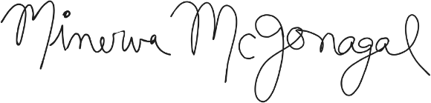
Minerva McGonagall
Deputy Headmistress

